A Project Report on

“SMART VEHICLE PARKING SYSTEM”

Submitted in partial fulfillment of the requirement for
Degree in Bachelor of Engineering (Information Technology)

By

Anish Xavier (501666)
Aniket Warade (501677)
Sachin Augustine (501410)

Guided by:

Prof. Trupti Lotlikar



Department of Information Technology
Fr. Conceicao Rodrigues Institute of Technology
Sector 9A, Vashi, Navi Mumbai–400703
University of Mumbai
2019-2020

CERTIFICATE

This is to certify that the project entitled

“SMART VEHICLE PARKING SYSTEM”

Submitted By

Anish Xavier | 501666
Aniket Warade | 501677
Sachin Augustine | 501401

In partial fulfillment of degree of B.E. in Information Technology for term work of the project is approved.

External Examiner Internal Examiner

External Guide Internal Guide

Head of the Department Principal

Date: - / /2020 College Seal

ii

DECLARATION

We declare that this written submission represents our ideas in our own words and where others ideas or words have been included; we have adequately cited and referenced the original sources. We also declare that we have adhered to all principles of academic honesty and integrity and have not misrepresented or fabricated or falsified any idea/data/fact/source in our submission. We understand that any violation of the above will be cause for disciplinary action by the Institute and can also evoke penal action from the sources which have thus not been properly cited or from whom proper permission has not been taken when needed.
.

--------------------------

Anish Xavier (501666)

---------------------------

Aniket Warade (501677)

--------------------------

Sachin Augustine (501410)

Date:
/ /2019

iii

ABSTRACT

As approximately every person has a vehicle for travelling to their office or for shopping, etc. but the problem of where to park these vehicles arises. So finding parking space is a problem for the driver. It takes a lot of time just finding a parking space.
But by using Smart Vehicle Parking System, an IOT based solution to overcome the problem, it becomes easier to get the legal parking space for the vehicles. When the driver brings the vehicle close to the gate it checks whether there is any free slot inside the parking area or not. If there is any parking space available the gate will open. Also to verify that the driver is authorized to park the vehicle the RFID reader is installed at the entrance of the gate so that only the driver who has permission to park a vehicle in that particular area should be allowed inside.
The LCD screen is configured to display if any slot is free or else the slots are full. IR sensors are used to check if any vehicle is parked at the given parking area. A major purpose of this system is to avoid unnecessary traveling by a driver for the parking area. Monitoring the whole area at the run time gives the driver an image of the entire parking area, and the user can select that free parking space. And also the illegal parking issues can be reduced with the help of this system.

iv
TABLE OF CONTENT

Sr. No. | Topic
1 | 1.1 Introduction  1.1.1 Background  1.1.2 Customer And Users  1.2 Literature Survey and Analysis
2 | Requirements
3 | System Design
4 | Sensor Configuration and Interfacing
5 | Implementation
6 | Code
7 | Result
8 | References
9 | Acknowledgements

vi

Chapter 1

INTRODUCTION
(Experiment 1)

1.1 INTRODUCTION

With the enhancements of the Internet of Things (IoT) that have been made in several areas of human lives, the traffic control and management systems are predominated, and for that, several intelligent solutions are implemented to manage the massive traffic crowd in metropolitan areas.
Typically, a long time ago, the human movements are massively increasing towards the big cities, in almost all over the world; therefore, the traffic issues are also increasing at the same time more especially in the cases of finding the parking places. Notably, the case of finding a parking place in a crowded city that has available parking lots is a big challenge, which has been faced by vehicle owners. The recently approaches employed to find the vehicle parking lots are manual; therefore the case of finding parking lots in the metropolitan city in a massive traffic crowd is a big task.

Finding parking space is a problem for the driver. Sometimes it kills a lot of time of driver to find a parking space. IoT based project smart parking system brings a solution. A major purpose of this project is to avoid unnecessary traveling by a driver for the parking area. Monitoring the whole area at the run time gives the driver an image of the entire parking area, and the user can select that free parking space. Rfid based security system is used to authenticate the user in the parking lot. It uses an IR sensor for detecting free parking space. Illegal parking can be reduced with this internet of things. This IoT based project is built on the Arduino board.

1.2. LITERATURE SURVEY

In today’s world parking lots have become redundant and need a lot of manpower to handle and maintain it. These parking lots are not user friendly and do not provide data regarding availability of free spaces. Many researchers have contributed to this issue and formalized with various methods to better optimize the parking lot to serve the needs.
The author proposed a smart parking reservation system using short message services (SMS), for which he uses Global System for Mobile (GSM) with microcontroller to enhance security [9]. The ZigBee technique is used along with the GSM module for parking management and reservation [11]. The author uses Global Positioning System (GPS) and Android platform to show available parking spaces. However, reservation for the same is not available [12].
Another proposed system uses a wide-angle camera as a sensor which detects only free parking spaces and records them. These records are then used to assign parking space to the incoming user [18]. Intelligent Transport System (ITS) and Electronic toll collection (ETC) using optical character recognition (OCR) creates a record for all entering vehicles. This creates tag less entry for all vehicles in the parking lot, but it does not assign a slot to the user. A universal OCR algorithm is not available, making it difficult to create said records [17].

Chapter 2
REQUIREMENTS
(Experiment 2)

REQUIREMENTS

Sr.No | Hardware Requirements | Sensors | Software Requirements
1 | Arduino Uno | IR Sensors | Arduino IDE
2 | 16*2 LCD Module | EM-18 RFID Reader Module
3 | Tower Pro MG995 Servo Motor

4.1 Hardware Requirements:

1.Arduino Uno

Arduino Uno is a microcontroller board based on the ATmega328P (datasheet). It has 14 digital input/output pins (of which 6 can be used as PWM outputs), 6 analog inputs, a 16 MHz quartz crystal, a USB connection, a power jack, an ICSP header and a reset button. It contains everything needed to support the microcontroller; simply connect it to a computer with a USB cable or power it with a AC-to-DC adapter or battery to get started.. You can tinker with your UNO without worrying too much about doing something wrong, worst case scenario you can replace the chip for a few dollars and start over again.
"Uno" means one in Italian and was chosen to mark the release of Arduino Software (IDE) 1.0. The Uno board and version 1.0 of Arduino Software (IDE) were the reference versions of Arduino, now evolved to newer releases. The Uno board is the first in a series of USB Arduino boards, and the reference model for the Arduino platform; for an extensive list of current, past or outdated boards see the Arduino index of boards.

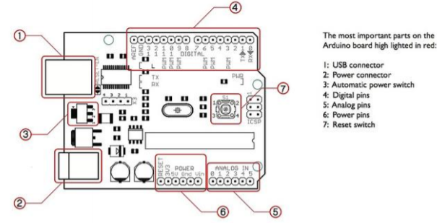

2. 16*2 LCD Module

LCD modules are very commonly used in most embedded projects, the reason being its cheap price, availability and programmer friendly. Most of us would have come across these displays in our day to day life, either at PCO’s or calculators. The appearance and the pinouts have already been visualized above now let us get a bit technical.
16×2 LCD is named so because; it has 16 Columns and 2 Rows. There are a lot of combinations available like, 8×1, 8×2, 10×2, 16×1, etc. but the most used one is the 16×2 LCD. So, it will have (16×2=32) 32 characters in total and each character will be made of 5×8 Pixel Dots. A Single character with all its Pixels is shown in the below picture.
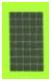
Now, we know that each character has (5×8=40) 40 Pixels and for 32 Characters we will have (32×40) 1280 Pixels. Further, the LCD should also be instructed about the Position of the Pixels. Hence it will be a hectic task to handle everything with the help of MCU, hence an Interface IC like HD44780 is used, which is mounted on the backside of the LCD Module itself. The function of this IC is to get the Commands and Data from the MCU and process them to display meaningful information onto our LCD Screen.

3. Tower Pro MG995 Servo Motor:

This is the most famous servo made by TowerPro.
MG995 is a digital metal gear high torque servo for airplane, helicopter, RC-cars from 10 to 6-th scale druggy and monster and many RC model.
MG995 is a servo motor that is popular for its performance and low price. The motor is used in many applications mainly being robotics and drones.
Since MG995 is a servo motor providing precise rotation over 180º range its applications are many and in them a few are stated below
- The servo is suited for designing robotic arm in which wear and tear of motor is high. Being metal geared, the servo has long life and can be installed on system like robotic arm were motor work is huge.
- The servo is also suited to be used in drones and toy planes. Having a satisfying torque which is enough to overcome air resistance and control wings of plane, the servo is preferred in toy planes and drones which need precision control no matter the condition.
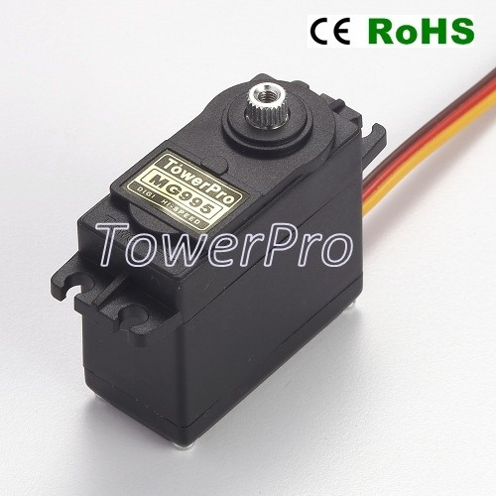

Applications
- Drones and RC planes
- Security camera
- Robotics
- Solar tracking and positioning
- Door lock and safe locks
- Hobby projects

4.2 Sensors:

1.IR Sensors:

IR Proximity sensor is a simple Infrared Sensor which is used to detect obstacles. This is a multipurpose sensor and used in many robotic applications like Obstacle avoidance robot, Line Follower Robot, and any other obstacle detection projects. This is an Active Infrared sensor; it emits and detects its own IR rays. A passive infrared sensor only detects the emitted IR Rays from objects. PIR Sensor is a good example for Passive IR Sensors.

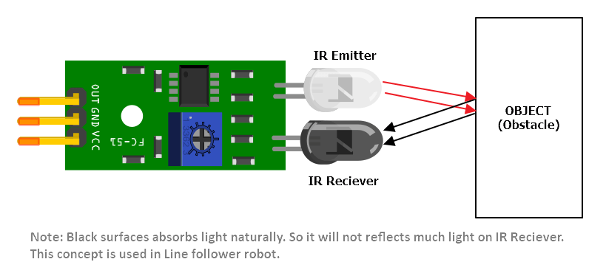
Vcc – Power Supply (+5V)
GND – Ground
OUT – Output

2. EM-18 RFID Reader Module
EM18 is a RFID reader which is used to read RFID tags of frequency 125 kHz.
After reading tags, it transmits unique ID serially to the PC or microcontroller using UART communication or Wiegand format on respective pins.
EM18 RFID reader reads the data from RFID tags which contains stored ID which is of 12 bytes.
EM18 RFID reader doesn’t require line-of-sight. Also, it has identification range which is short i.e. in few centimetres.
RFID reader EM-18 features:
1. Serial RS232/TTL output
2. Operating Frequency is 125KHz.
3. Range is 5-8 cm.
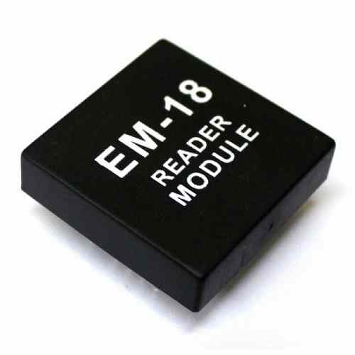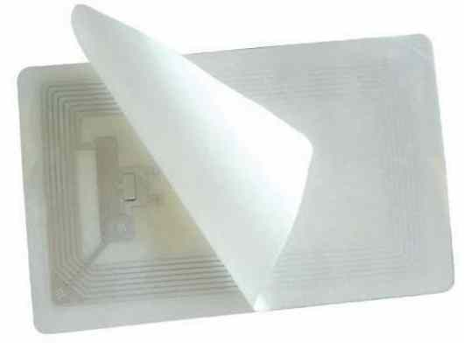

4.2 Software Requirements

- Arduino IDE
The Arduino integrated development environment is a cross-platform application that is written in the programming language Java. It is used to write and upload programs to Arduino board. The source code for the IDE is released under the GNU General Public License, version 2.

Chapter 3
SYSTEM DESIGN
(Experiment 3)

  - System Design
Arduino UNO is the microcontroller used in our System which is the core component to control and manage all the sensors and hardwires throughout the system. It’s a low-cost microcontroller which can serve the purpose for our Smart Vehicle Parking System.

A 16*2 LCD module is used to display the free slots and used slots in the parking lot while a Potentiometer is used to control the contrast of LCD.

The EM-18 reader module is used to authenticate the users entering into the parking lot, it’s a read only module which can only read the tags, tag numbers of registered users are only accepted. A buzzer built into this module will beep once a RFID tag is detected.

An IR sensor is placed into each parking slot of check if a Vehicle is present or not. This data is used to print on LCD.

Servo motor acts as a gate, if authenticated RFID tag is identified it will open the gate for Vehicle entry and if unregistered/new RFID tags detected the gate will not open for Vehicle entry.

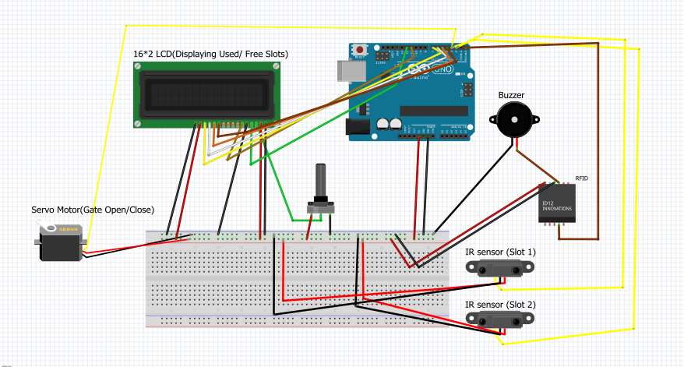

Chapter 4

SENSOR CONFIGURATION AND INTERFACING
(Experiment 4)

SENSOR CONFIGURATION AND INTERFACING

4.1. IR Sensor

The purpose of the IR sensor in our project is to detect the presence of Vehicle in a parking slot.

The connections for the IR sensor with the Arduino are as follows:
  - Connect the GND pin on the IR sensor to GND on the Arduino.
  - Connect the middle of the IR sensor which is the VCC to 5V on the Arduino.
  - Connect the signal pin on the IR sensor to one of the unused data pins on the Arduino.

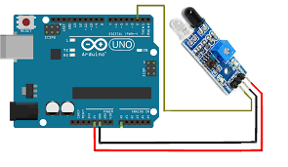

4.2. EM-18 RFID module:

EM-18 RFID reader is one of the commonly used RFID reader to read 125KHz tags. It features low cost, low power consumption, small form factor and easy to use. It provides both UART and Wiegand26 output formats. It can be directly interfaced with microcontrollers using UART and with PC using an RS232 converter.

The connections of EM-18 RFID reader with Arduino are as follows:
  - Connect GND pin of RFID reader to GND pin of Arduino.
  - Connect Vcc pin to +5 v supply of Arduino.
  - Connect Buzz pin to Vcc pin of Buzzer if Buzzer is to be used.
  - Connect Tx pin of reader with Rx pin of Arduino.

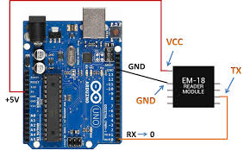

Chapter 5
IMPLEMENTATION
(Experiment 5)

IMPLEMENTATION

5.1 Implementation
Steps:
Step 1: Gather what is needed to build the project
- Arduino UNO
- 16*2 LCD
- Tower Pro MG995 Servo Motor
- IR Sensors
- EM-18 RFID Reader
- Breadboard
- Jumper Wires
- Buzzer
- Potentiometer
Step 2: Summing up the Circuit
Fig 5.1 Circuit Diagram
Arduino UNO is the microcontroller used in our System which is the core component to control and manage all the sensors and hardwires throughout the system. It’s a low-cost microcontroller which can serve the purpose for our Smart Vehicle Parking System.
A 16*2 LCD module is used to display the free slots and used slots in the parking lot while a Potentiometer is used to control the contrast of LCD.
The EM-18 reader module is used to authenticate the users entering into the parking lot, it’s a read only module which can only read the tags, tag numbers of registered users are only accepted. A buzzer built into this module will beep once a RFID tag is detected.
An IR sensor is placed into each parking slot of check if a Vehicle is present or not. This data is used to print on LCD.
Servo motor acts as a gate, if authenticated RFID tag is identified it will open the gate for Vehicle entry and if unregistered/new RFID tags detected the gate will not open for Vehicle entry.
Step 3: Uploading the code on IDE
1) Connect your Arduino using the USB cable.
2) Choose Tools→Board→Node MCU to find your board in the Arduino menu.
3) Choose the correct serial port for your board.
4) Click the Upload button.
This is the button that points to the right in the Arduino environment. The Arduino also stores the program in its memory so it does not require re-uploading of Program.

Chapter 6

CODE UPLOADING
(Experiment 6)

CODE UPLOAD

- Install Arduino IDE.
Steps:
1.The Linux build of the Arduino Software (IDE) is now a package that doesn't require any specific procedure for the various distributions availabe of Linux. The only relevant information is the 32 or 64 bit version of the OS.
2.Download the Arduino Software (IDE):Get the latest version from the download page. You can choose between the 32, 64 and ARM versions. It is very important that you choose the right version for your Linux distro. Clicking on the chosen version brings you to the donation page and then you can either open or save the file. Please save it on your computer.
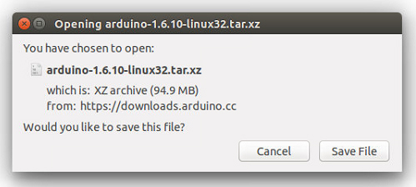

3.Extract the package
The file is compressed and you have to extract it in a suitable folder, remembering that it will be executed from there.
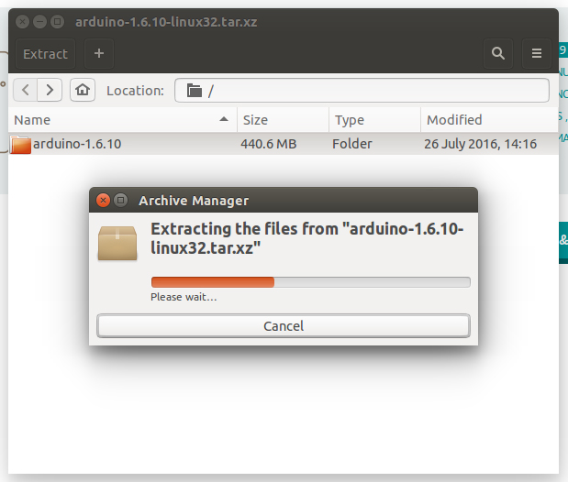

4.Run the install script
Open the arduino-1.6.x folder just created by the extraction process and spot the install.sh file. Right click on it and choose Run in Terminal from the contextual menu. The installation process will quickly end and you should find a new icon on your desktop.
If you don’t find the option to run the script from the contextual menu, you have to open a Terminal window and move into the arduino-1.6.x folder. Type the command ./install.sh and wait for the process to finish. You should find a new icon on your desktop.
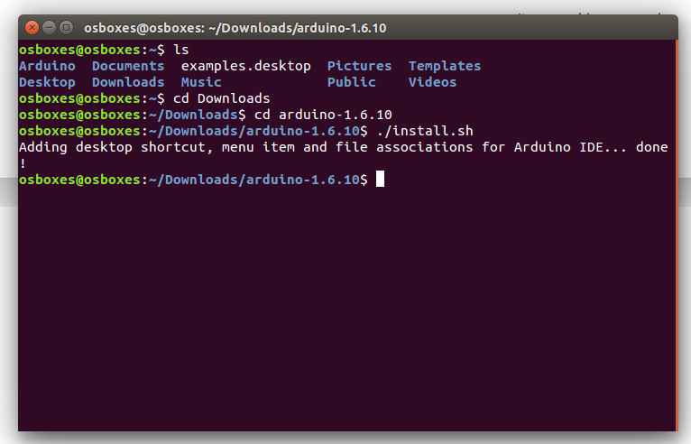

3.1 Arduino Code ( Upload the following code in arduino using arduino IDE)

#include <LiquidCrystal.h>
#include <Servo.h>

Servo myservo; // create servo object to control a servo
// a maximum of eight servo objects can be created
int pos = 0; // variable to store the servo position
int count = 0;
char input[12];
boolean flag = 0;
int IRSensor1 = 4;
int IRSensor2 = 3; // connect ir sensor to arduino pin 2
const int rs = 8, en = 2, d4 = 13, d5 = 12, d6 = 11, d7 = 10;
LiquidCrystal lcd(rs, en, d4, d5, d6, d7);
void setup()
{
Serial.begin(9600);
myservo.attach(9);
pinMode (IRSensor1, INPUT); // sensor pin INPUT
pinMode (IRSensor2, INPUT); // sensor pin INPUT
//LCD
Serial.begin(9600);
// set up the LCD's number of columns and rows:
lcd.begin(16, 2);
lcd.setCursor(0,0);
lcd.print("All Slots are available");
for (int scrollCounter = 0; scrollCounter < 28; scrollCounter++)
{

lcd.scrollDisplayLeft();
delay(200);
}

}

void loop()
{
lcd.display();
int statusSensor1 = digitalRead (IRSensor1);
int statusSensor2 = digitalRead (IRSensor2);
if (statusSensor1 == 0 && statusSensor2 == 0)
{

myservo.attach(9);
servoandrfid();
lcd.setCursor(0,0);
lcd.print("All Slots are available");
for (int scrollCounter = 0; scrollCounter < 28; scrollCounter++)
{
lcd.scrollDisplayLeft();
delay(200);
}
lcd.clear();
lcd.display();
}else if (statusSensor1 == 1 && statusSensor2 == 0)
{

myservo.attach(9);
servoandrfid();
lcd.setCursor(0,0);
lcd.print("Slot 1 Booked");

lcd.setCursor(0,1);
lcd.print("Slot 2 Available");

lcd.clear();
lcd.display();
}else if (statusSensor1 == 0 && statusSensor2 == 1)
{
myservo.attach(9);

servoandrfid();

lcd.setCursor(0,0);
lcd.print("Slot 1 Available");

lcd.setCursor(0,1);
lcd.print("Slot 2 Booked");

lcd.clear();
lcd.display();

}else if (statusSensor1 == 1 && statusSensor2 == 1)
{

myservo.detach();
delay(500);
lcd.setCursor(0,0);
lcd.print("All Slots are booked");
for (int scrollCounter = 0; scrollCounter < 28; scrollCounter++)
{

lcd.scrollDisplayLeft();

delay(200);
}

lcd.clear();
lcd.display();
}

}
void servoandrfid()
{

int Sensor1 = digitalRead (IRSensor1);
int Sensor2 = digitalRead (IRSensor2);
if(Serial.available())
{
count = 0;
while(Serial.available() && count < 12) // Read 12 characters and store them in input array
{
input[count] = Serial.read();
count++;
delay(5);
}
Serial.print(input); // Print RFID tag number

if((input[0] ^ input[2] ^ input[4] ^ input[6] ^ input[8] == input[10]) &&
(input[1] ^ input[3] ^ input[5] ^ input[7] ^ input[9] == input[11]))
{
for(pos = 0; pos < 95; pos += 1) // goes from 0 degrees to 180 degrees
{ // in steps of 1 degree
myservo.write(pos); // tell servo to go to position in variable 'pos'
delay(16); // waits 15ms for the servo to reach the position
}
delay(2500);
for(pos = 95; pos>=1; pos-=1) // goes from 180 degrees to 0 degrees
{
myservo.write(pos); // tell servo to go to position in variable 'pos'
delay(16); // waits 15ms for the servo to reach the position
}
}else{
myservo.detach();
}
}
}

Chapter 7
Result
(Experiment 7)

Result

1. The overall connection of all components i.e. RFID reader, Servo motor, IR sensors, 16*2 LCD

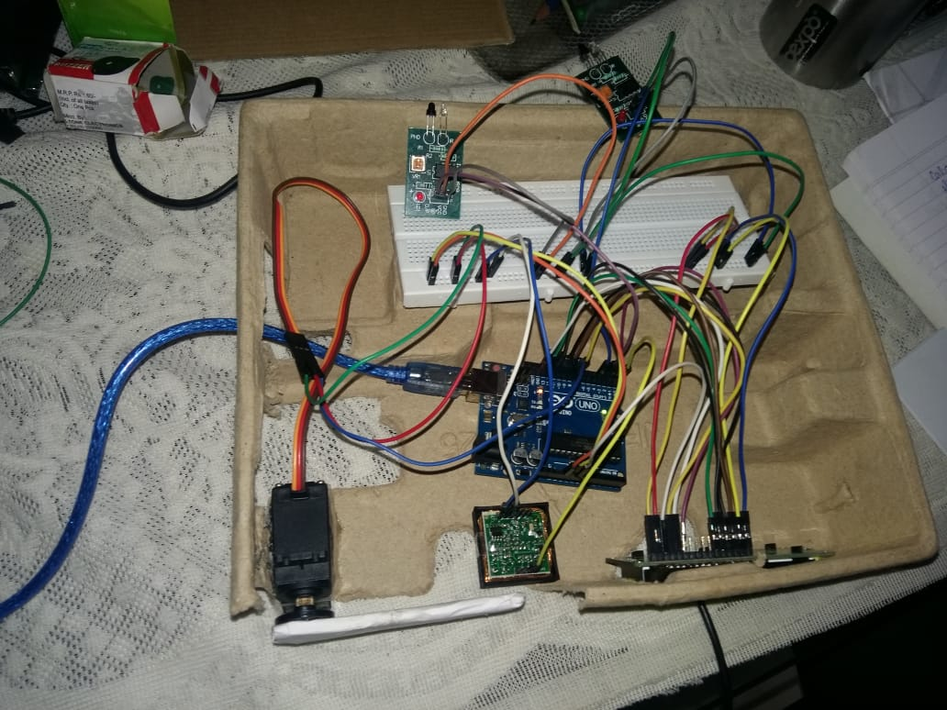

2. The LCD showing both slots free
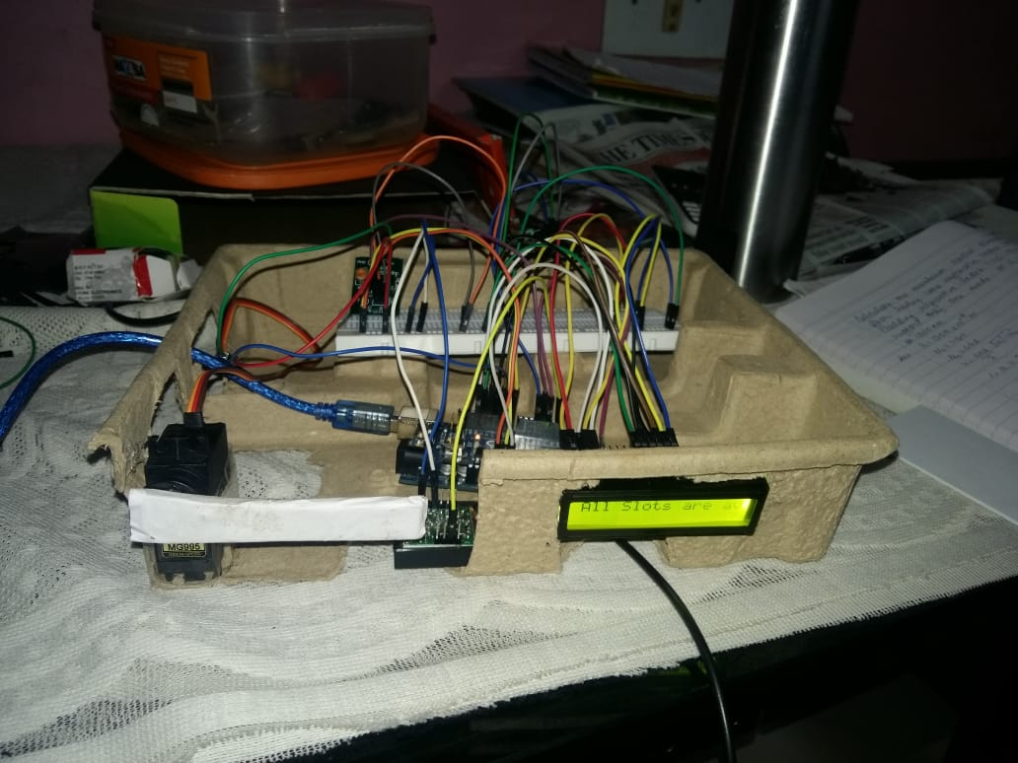

3. Servo motor opens gate on detection of Authenticated RFID tag

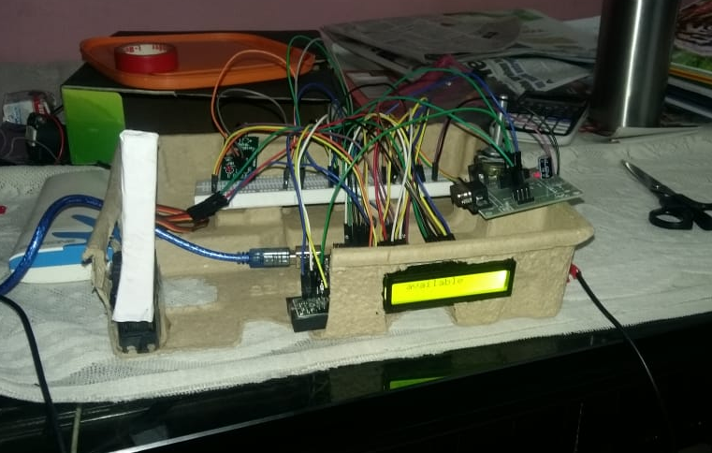

4. Final Project after finishing cardboard works

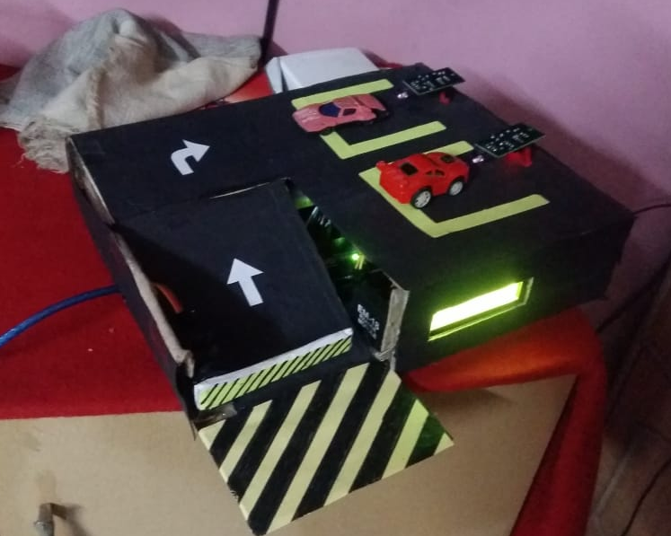

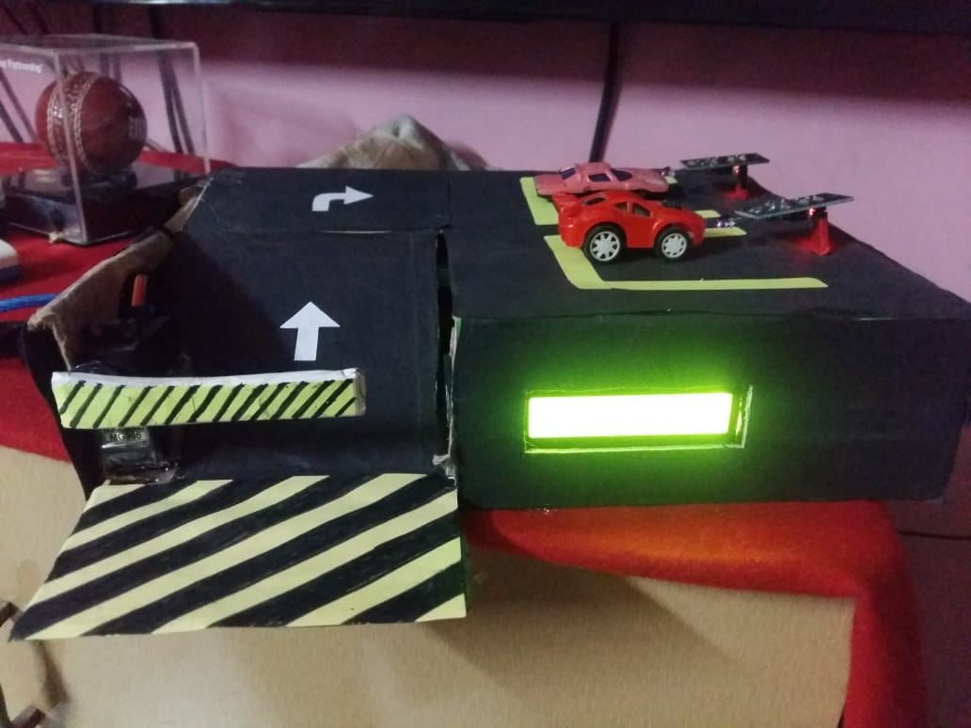

REFERENCES

[1] Supriya Shinde1, AnkitaM Patial2, pSusmedha Chavan3,Sayali Deshmukh4, and Subodh Ingleshwar5 “IOT Based Parking System Using Google”, I-SMAC,2017,pp.634-636.

[2] HemantChaudhary, PrateekBansal., B.Valarmathi,” Advanced CAR Parking System using Arduino”, ICACCSS, 2017.
3. Nastaran Reza NazarZadeh, Jennifer C. Dela,”Smart urban parking deducting system” ICSCE, 2016, pp-370-373.

[4] PavanKumarJogada and VinayakWarad, “Effective Car Parking Reservation System Based on Internet of things Technologies “.BIJSESC, 2016, Vol. 6, pp.140-142.

[5] Prof. Yashomati R. Dhumal1, Harshala A. Waghmare2, Aishwarya S. Tole2, Swati R. Shilimkar2,”Android Based Smart Car Parking System”-IJREEIE, Vol. 5, Issue 3, pp-1371-74,mar-2016.

[6] Faiz Ibrahim Shaikh, Pratik NirnayJadhav, Saideep Pradeep Bandarakar” Smart Parking System based on embedded system and sensor Network” IJCA, vol.140.pp.45-51.Apr-2016.

[7] RicardGarra, Santi Martinez, and Francesc Seb‟e” A PrivacyPreserving Pay-by-phone Parking system”IEEE-TVT, pp.1-10, Dec2016.

[8] Amir O. Kotb, Yao-chunShen, and Yi Huang “Smart parking Guidance, Monitoring and Reservation: A Review,” IEEE-ITSM, pp.6- 16.Apr-2017.

[9] Ching-FeiYang, You-HueiJu, Chung-Ying Hsieh “Iparking -a real-time parking space monitoring and guiding system”, Elsevier, pp.301-305. Apr-2017.

[10] Fei-Yue Wang, Liu-Qing Yang, Fellow, Jian Yang,” Urban Intelligent Parking system based on Parallel Theory”, IEEE-ICNC, 2016.

[11] Fei-Yue Wang, Liu-Qing Yang, Fellow, Jian Yang, [2016],” Urban Intelligent Parking system based on Parallel Theory”, IEEEComputing, Networking and Communications, Mobile Computing and Vehicle Communications.

[12] TarekAlmahdi and chittrurivenkatratnum, [2016]”Intelligent automated parking System hacking intimation Features,”IEEE-computing and engineering.

ACKNOWLEDGEMENT

The making of the project “Smart Vehicle Parking System” involves contribution of many people.

We would take this opportunity to thank our guide Prof. Trupti Lotlikar for guiding and correcting various documents of ours with attention and care. This synopsis could not have been completed without their knowledge and expertise.

We would also thank our Institution and our faculty members without whom this project would have been a distant reality. We also extend our heartfelt thanks to our families and well-wishers.

Yours Sincerely,

Anish Xavier

Aniket Warade

Sachin Augustine

